[Selenium Java 2025 - YouTube](https://www.youtube.com/playlist?list=PLhW3qG5bs-L_zQUmcXPs0F_e159DZ8OrP)

| Component | Version / Notes |

| ------------- | -------------------------------------------------------------- |

| Eclipse IDE | **2025‑06 (4.36.0)** – Known to fully work with TestNG plugin |

| TestNG Plugin | **7.11.0** – Latest stable plugin compatible with Eclipse 4.36 |

| Maven | **3.9.11** – Works fine with any Eclipse version |

| Java JDK | **17+** (you have 24, which is fine) |

| Selenium Java | Latest 4.x (e.g., 4.19.0 or above) |

**✅ Recommended Versions (Stable Compatibility)**

| **Component** | **Version / Notes** |
| --- | --- |
| Eclipse IDE | **2025‑06 (4.36.0)** – Known to fully work with TestNG plugin |
| TestNG Plugin | **7.11.0** – Latest stable plugin compatible with Eclipse 4.36 |
| Maven | **3.9.11** – Works fine with any Eclipse version |
| Java JDK | **17+** (you have 24, which is fine) |
| Selenium Java | Latest 4.x (e.g., 4.19.0 or above) |

Using Eclipse 2025‑09 (4.37.0) breaks TestNG integration. 2025‑06 (4.36) is fully stable.

**Step 1: Install Eclipse 2025‑06**

1. Go to the Eclipse download page:  
   https://www.eclipse.org/downloads/packages/release/2025-06
2. Download **Eclipse IDE for Java Developers**.
3. Extract the ZIP → Open eclipse.exe.
4. Set a workspace folder (e.g., D:\eclipse-workspace).

**Step 2: Install Maven (if not already)**

1. Download Apache Maven 3.9.11:  
   https://maven.apache.org/download.cgi
2. Extract to a folder, e.g., D:\eclipse\maven\apache-maven-3.9.11
3. Add bin folder to **Windows PATH**:
4. D:\eclipse\maven\apache-maven-3.9.11\bin
5. Verify installation:
6. mvn -v

Output should show Maven version.

**Step 3: Configure Maven in Eclipse**

1. Open Eclipse → **Window → Preferences → Maven → Installations**
2. Click **Add…** → Point to your Maven folder (D:\eclipse\maven\apache-maven-3.9.11)
3. Set it as default → Apply and Close

**Step 4: Install TestNG Plugin**

1. Go to **Help → Eclipse Marketplace**
2. Search: TestNG → Select **TestNG for Eclipse** by **Cédric Beust**
3. Install → Accept License → Restart Eclipse
4. Verify: **Help → About Eclipse → Installation Details → TestNG plugin should be listed**

**Step 5: Create Maven Project in Eclipse**

1. **File → New → Maven Project**
2. Choose **Create a simple project (skip archetype selection)** → Next
3. Set Group Id and Artifact Id (e.g., com.selenium / selenium-automation) → Finish

**Step 6: Add Dependencies in pom.xml**

<dependencies>

<!-- Selenium Java -->

<dependency>

<groupId>org.seleniumhq.selenium</groupId>

<artifactId>selenium-java</artifactId>

<version>4.19.0</version>

</dependency>

<!-- TestNG -->

<dependency>

<groupId>org.testng</groupId>

<artifactId>testng</artifactId>

<version>7.9.0</version>

<scope>test</scope>

</dependency>

<!-- SLF4J Logger (optional) -->

<dependency>

<groupId>org.slf4j</groupId>

<artifactId>slf4j-simple</artifactId>

<version>2.0.9</version>

</dependency>

</dependencies>

* Right-click project → **Maven → Update Project → Force Update**

**Step 7: Create a TestNG Test Class**

import org.testng.annotations.Test;

import org.openqa.selenium.WebDriver;

import org.openqa.selenium.chrome.ChromeDriver;

public class FirstTest {

@Test

public void openGoogle() {

System.setProperty("webdriver.chrome.driver", "D:\\drivers\\chromedriver.exe");

WebDriver driver = new ChromeDriver();

driver.get("https://www.google.com");

System.out.println("Title: " + driver.getTitle());

driver.quit();

}

}

**Step 8: Run as TestNG Test**

1. Right-click your class → **Run As → TestNG Test**
2. TestNG results will show in Eclipse console.

If it doesn’t show, go to **Run → Run Configurations → TestNG → New → select class → Run**

[SeleniumAutomationFramework2025/src/main/resources/log4j2.xml at master · Raghav-Pal/SeleniumAutomationFramework2025 · GitHub](https://github.com/Raghav-Pal/SeleniumAutomationFramework2025/blob/master/src/main/resources/log4j2.xml)

1. Checked java : java –version
2. Check java compiler: javac –versions
3. Download the zip file: <https://www.eclipse.org/downloads/download.php?file=/technology/epp/downloads/release/2025-09/R/eclipse-java-2025-09-R-win32-x86_64.zip>
4. Unzip at you r location such as d drive create folder eclipse
5. Double click on eclips.exe
6. Create folder projects and install
7. Check maven is installed
8. Installed maven: <https://maven.apache.org/download.cgi>
9. Binary zip archive
10. Create new folder maven at d driver and extract zip file
11. Set up the environment variables and after tha chek the command prompt with maven – v

C:\Users\lenovo>mvn -v

Apache Maven 3.9.11 (3e54c93a704957b63ee3494413a2b544fd3d825b)

Maven home: D:\eclipse\maven\apache-maven-3.9.11

Java version: 24.0.2, vendor: Oracle Corporation, runtime: C:\Program Files\Java\jdk-24

Default locale: en_US, platform encoding: UTF-8

OS name: "windows 10", version: "10.0", arch: "amd64", family: "windows"

1. Create a maven project:
2. 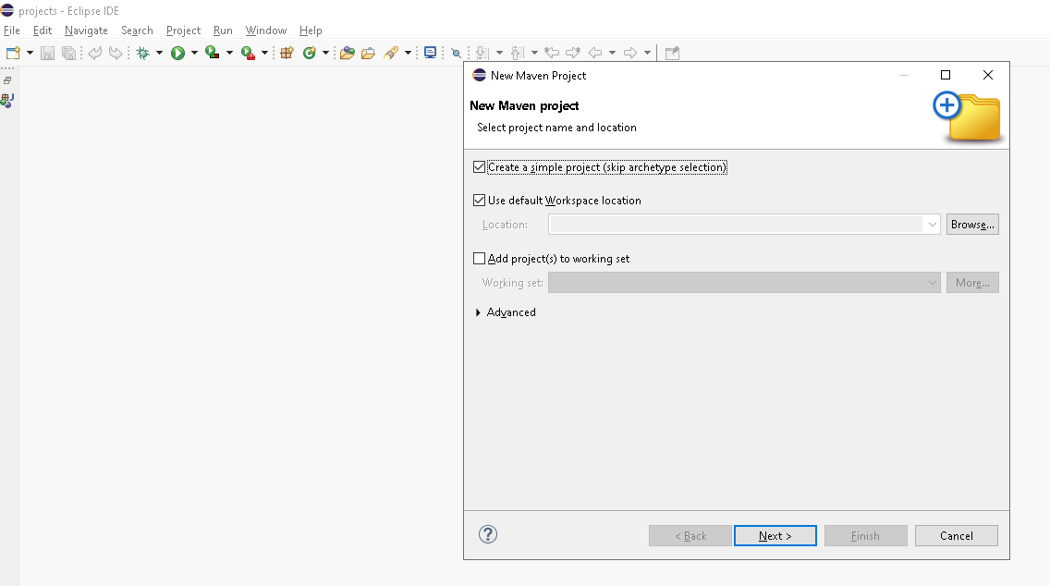
3. 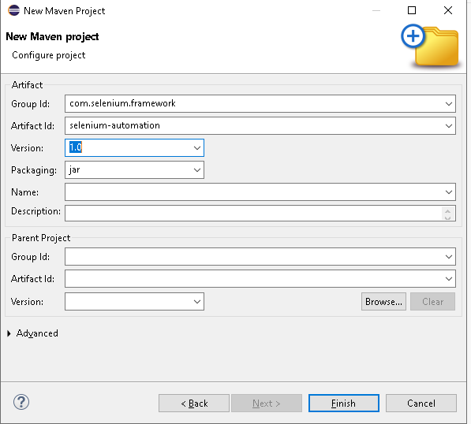
4. Click finish
5. Install the all the dependencies
6. Copy the maven dependencies: <https://mvnrepository.com/artifact/org.seleniumhq.selenium/selenium-java/4.35.0>
7. 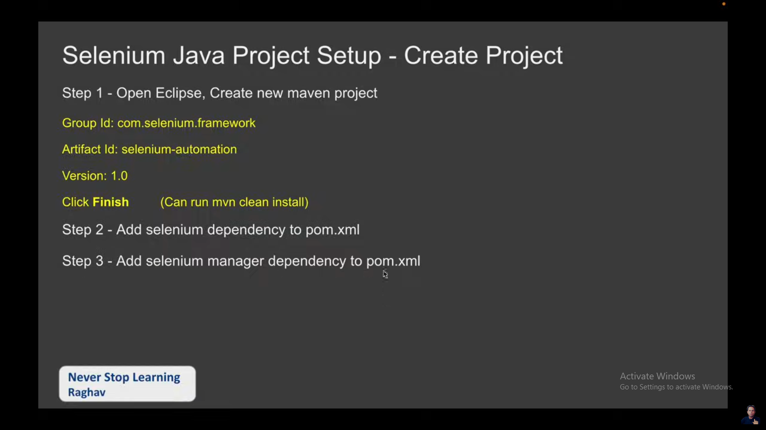
8. 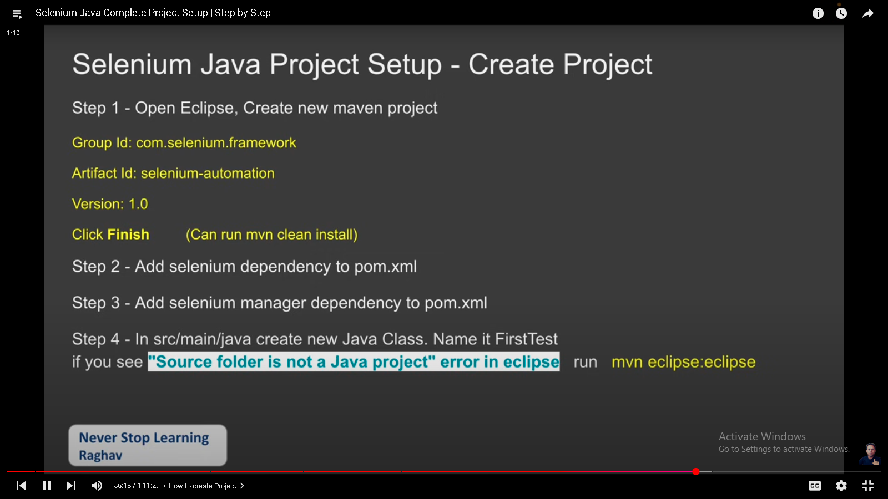
9. Install testng : <https://mvnrepository.com/search?q=testng>
10. <https://mvnrepository.com/artifact/org.testng/testng/7.10.2>
11. 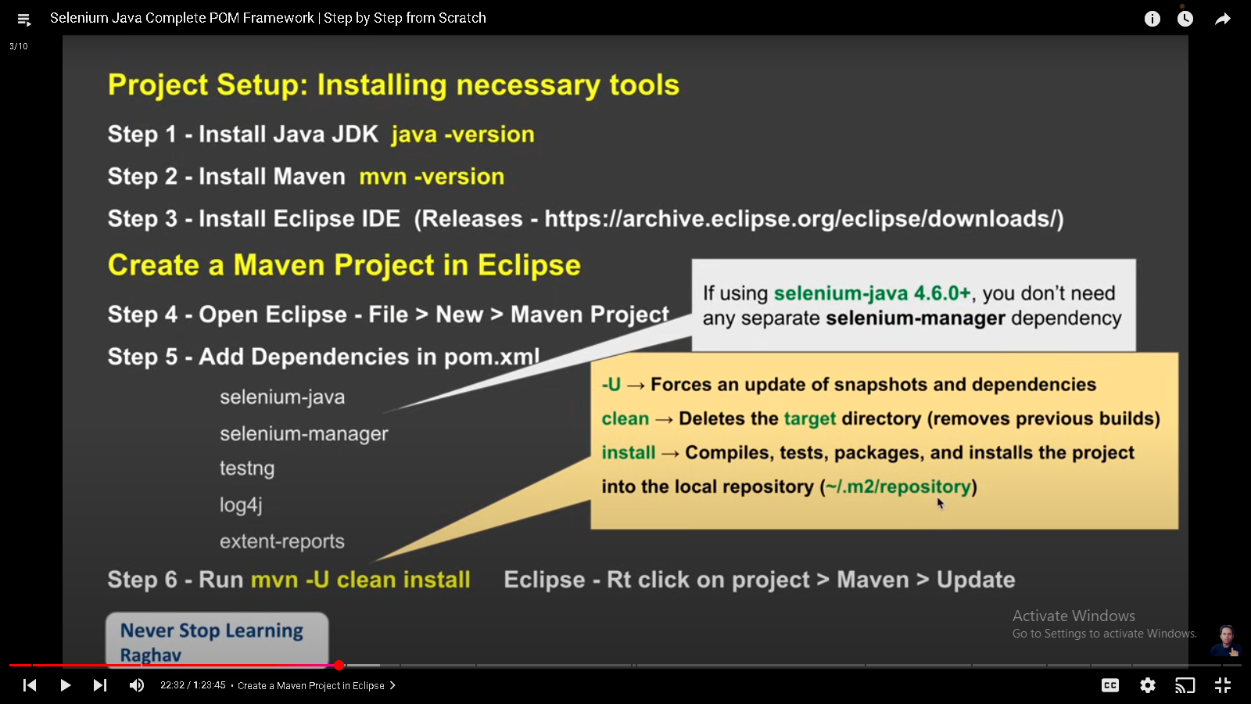
12. Create two packages base and pages
13. 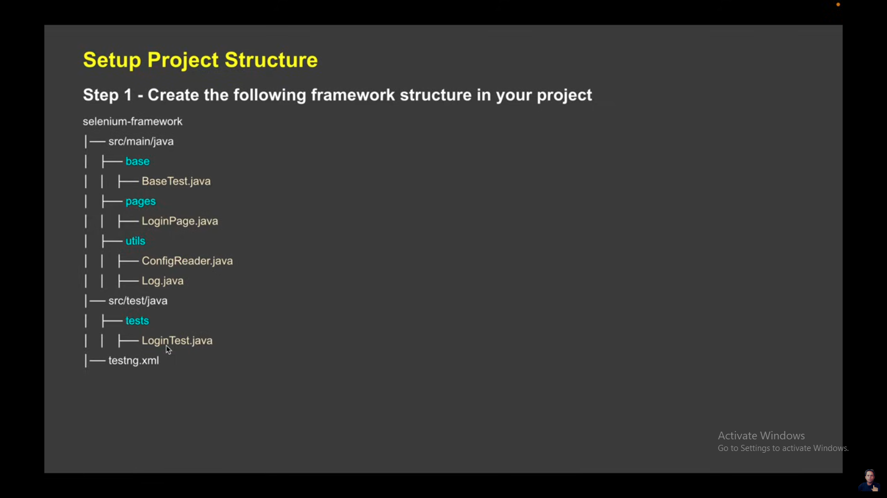
14. Create testng.xml file on root level
15. 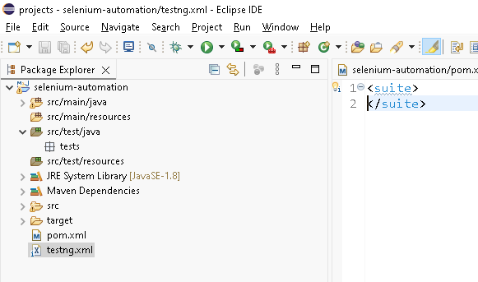
16. 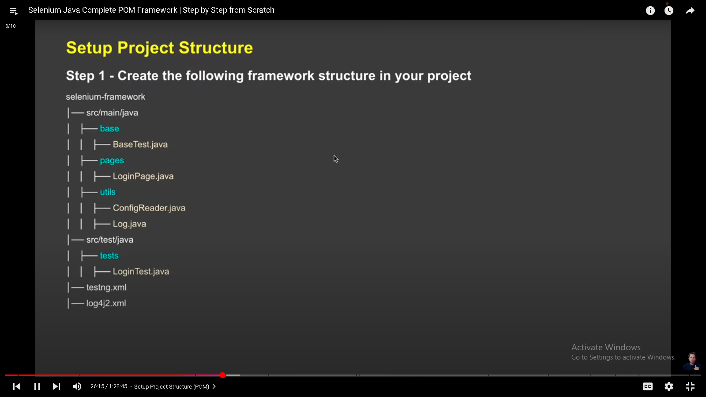
17. 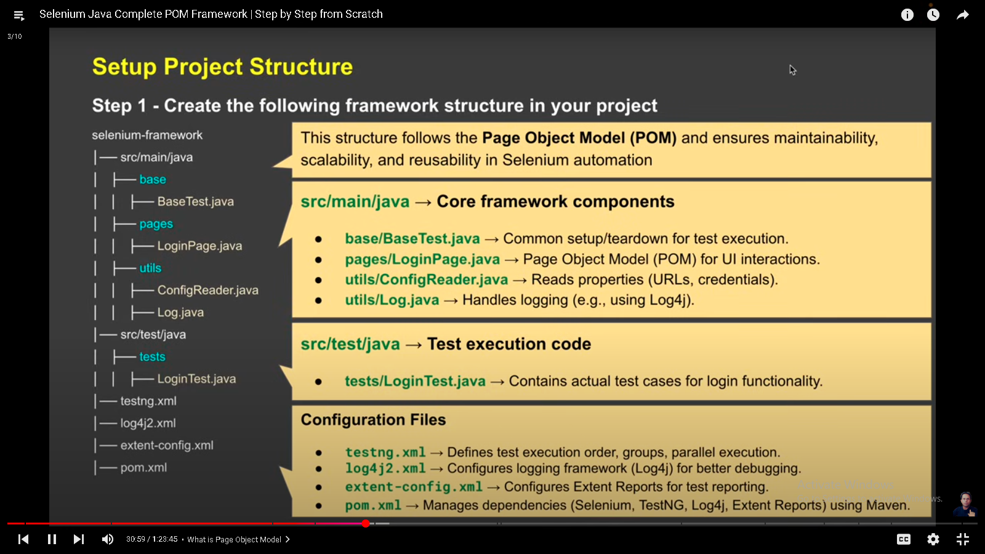
18. 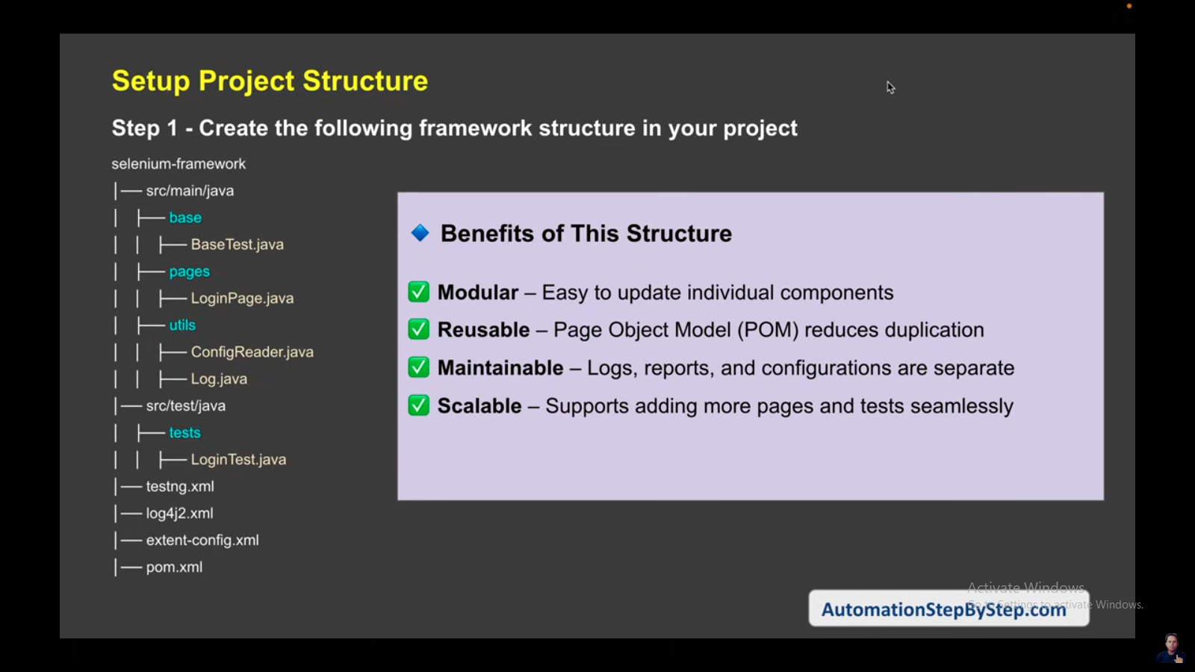
19. 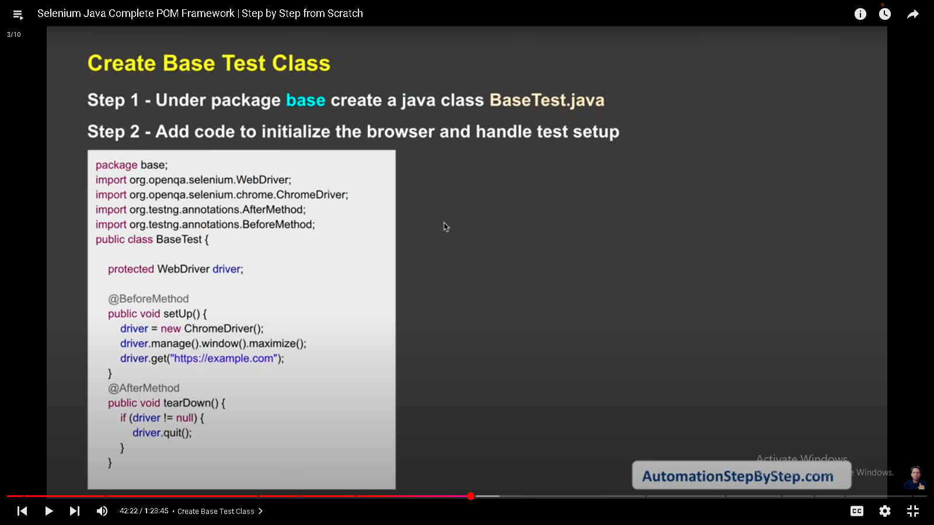

Locators: <https://www.selenium.dev/documentation/webdriver/elements/locators/>

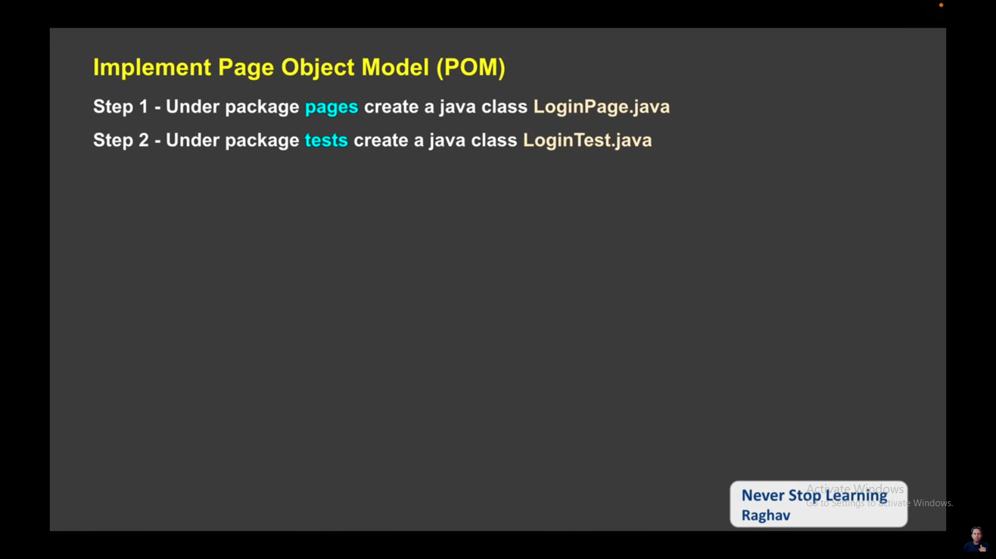

Install testng reference for execute the testng test

1. Go to help
2. Click on install new software
3. Go to the link: <https://testng.org/testng-eclipse/download>
4. Copy and paste this link: <https://testng.org/testng-eclipse-update-site>.
5. Click on Add and give the nameas TestNG
6. Select all checkboxes and click next
7. 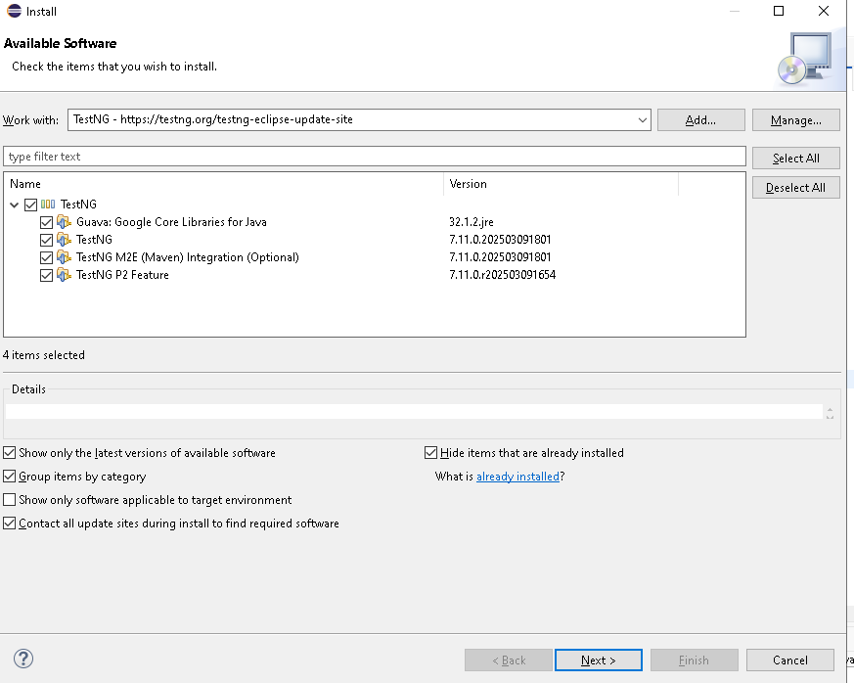
8. Click next
9. Accept the term and conditions
10. Trusted and click Trust Selected
11. Restart Now
12. 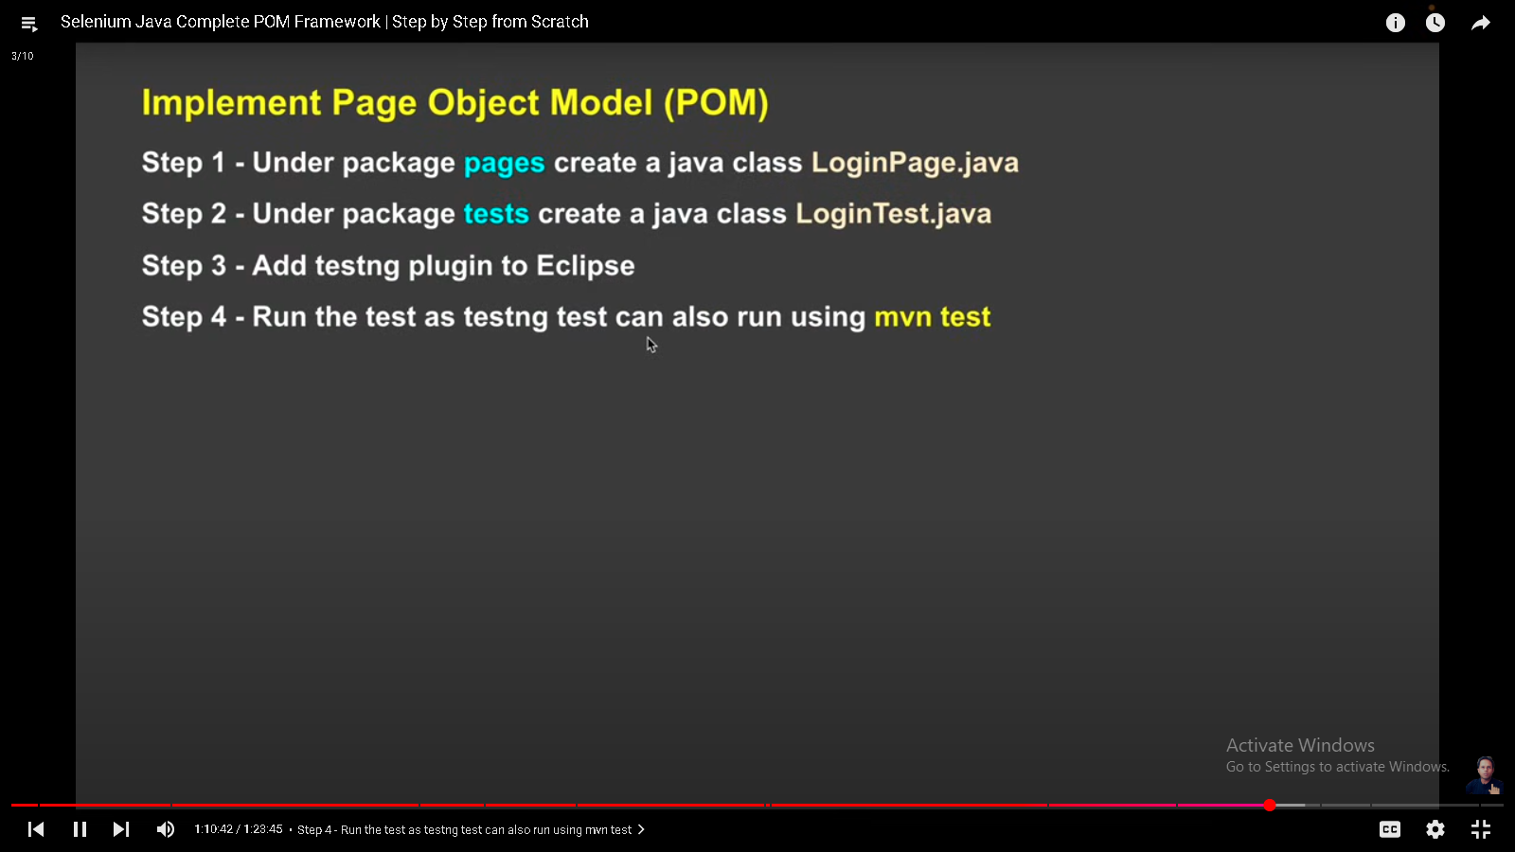
13. OTHER OPTIONS:
14. 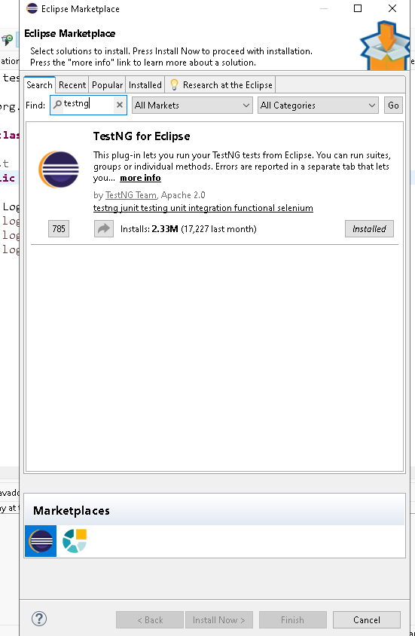

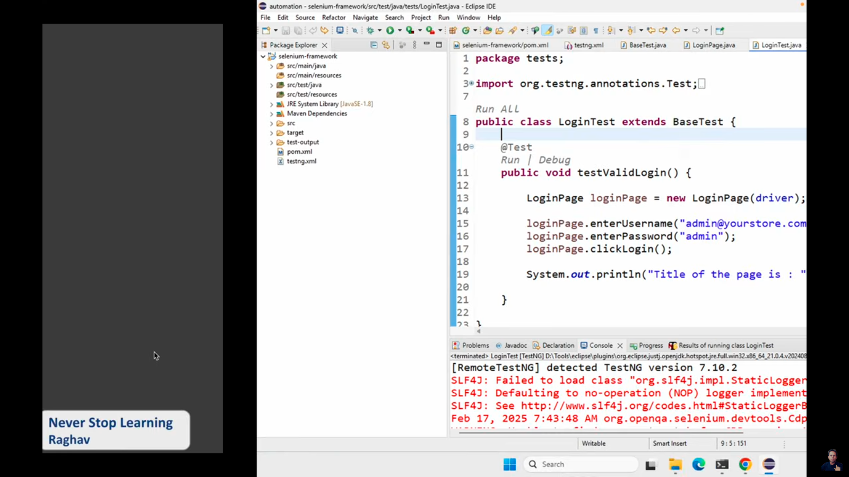

INSTALL GIT

Go to the command prompt and move to the project folder and and run the command: git init

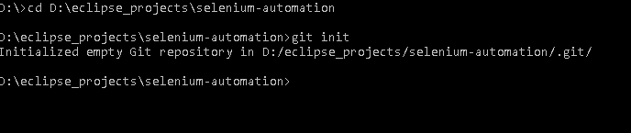

GIT <https://github.com/sainiashu/sel_java.git>

D:\eclipse_projects\selenium-automation>git remote add origin <https://github.com/sainiashu/sel_java.git>

Create .gitignore file into the root folder

You can generate all line: <https://www.git-tower.com/free-tools/gitignore>

Pass the value java,eclipse, maven

Copy the code and paste in to the .gitignore file

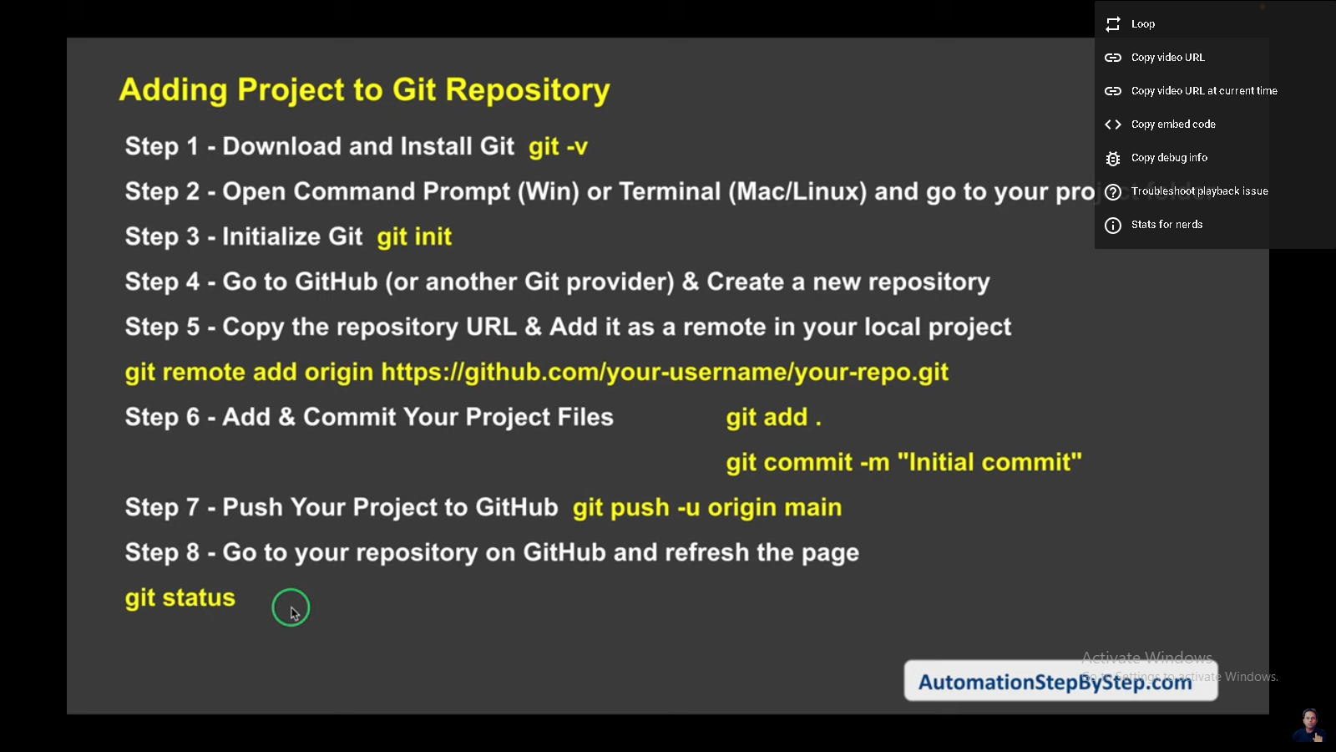

NOW ADDING LOG4J2

GO TO THE PROJECT AND OPEN POM.XML

<https://mvnrepository.com/artifact/org.apache.logging.log4j/log4j-core/2.25.1>

<https://mvnrepository.com/artifact/org.apache.logging.log4j/log4j-api/2.25.1>

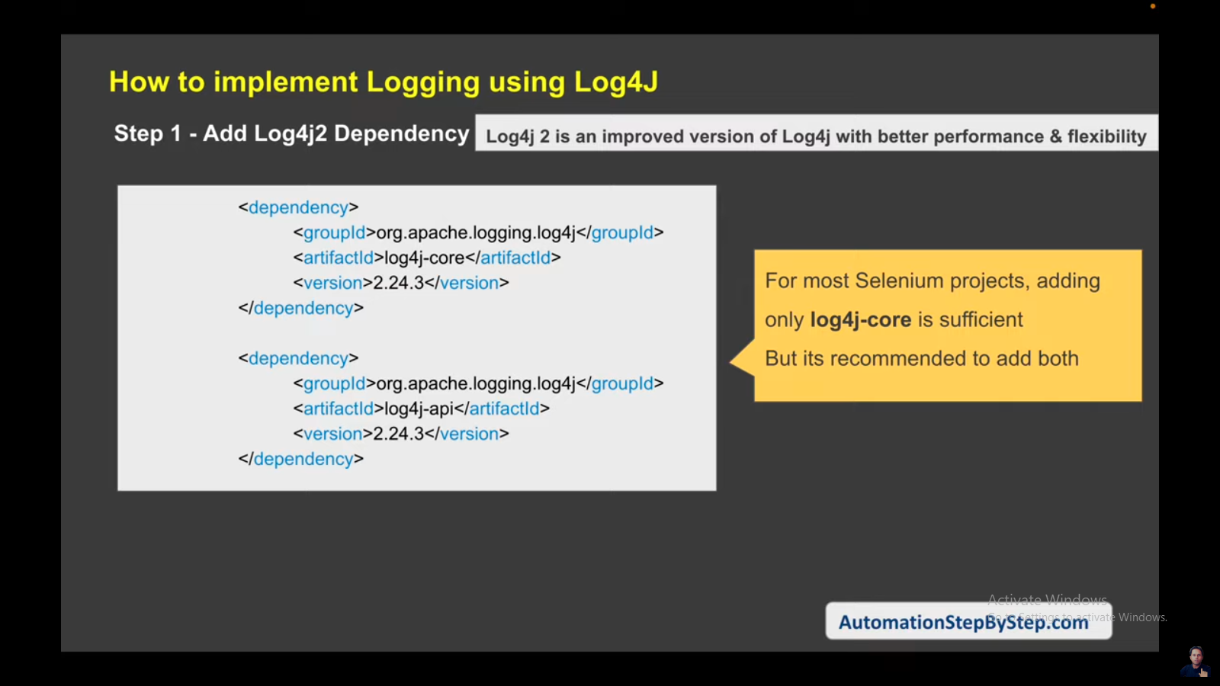

GO TO YOUR log4j2.xml

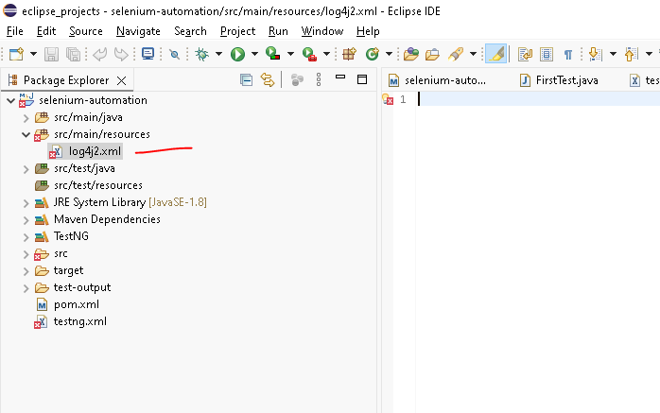

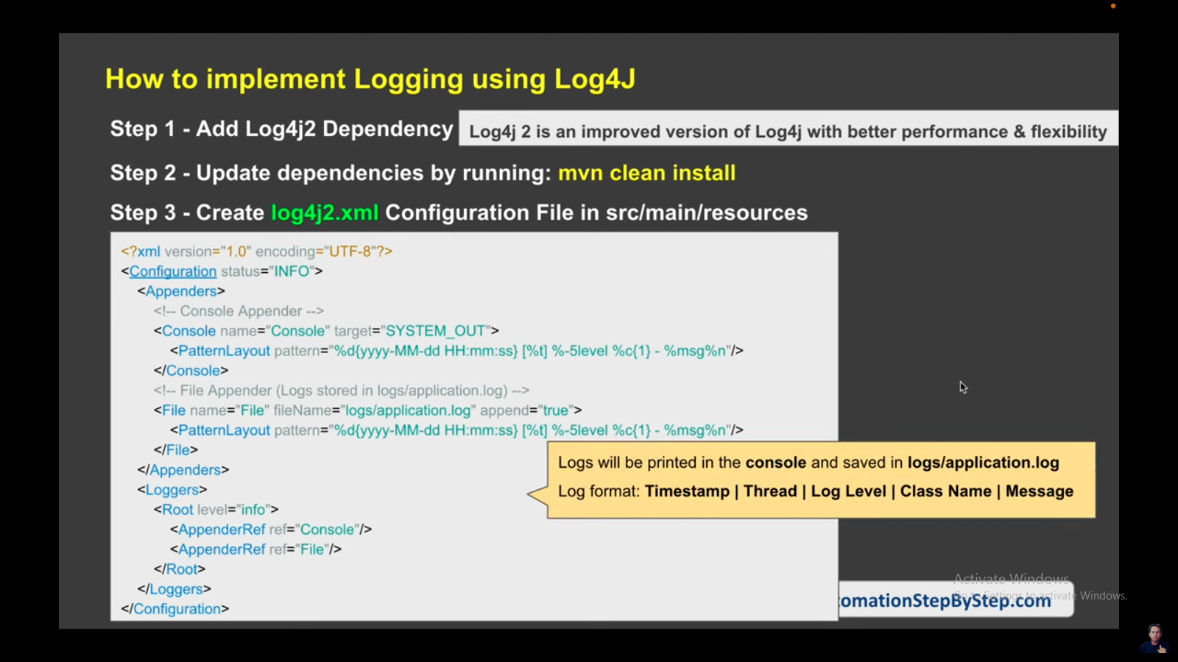

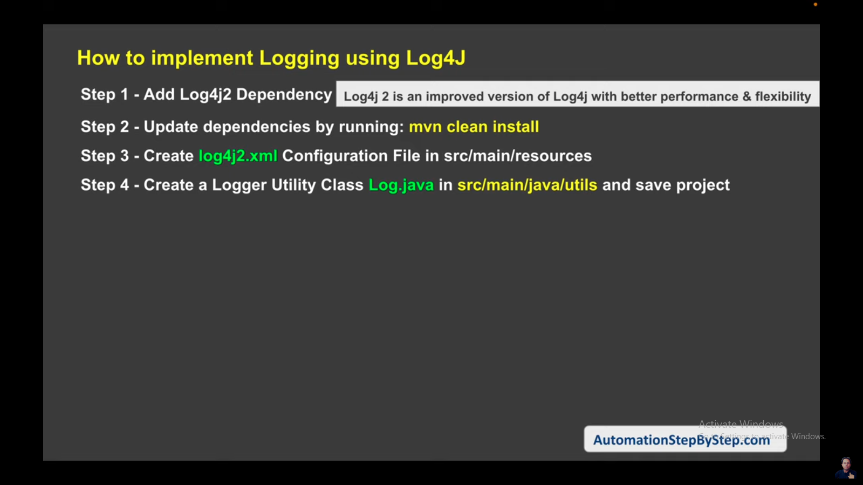

CREATE A LOG.JAVA FILE UNDER UTILS PACKAGES

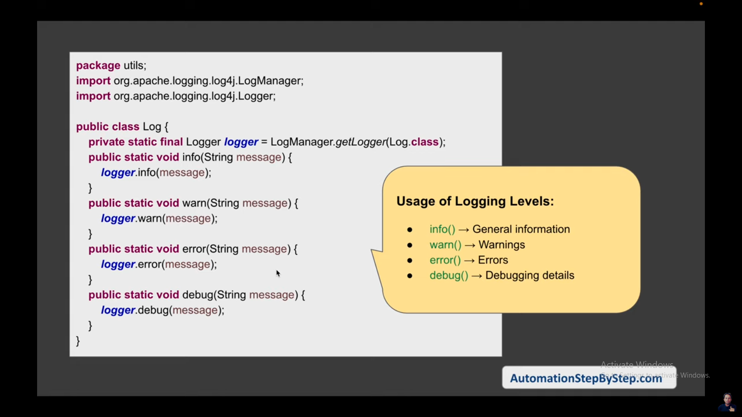

**package** utils;

**import** org.apache.logging.log4j.LogManager;

**import** org.apache.logging.log4j.Logger;

**public** **class** Log {

**private** **static** **final** Logger ***logger*** = LogManager.*getLogger*();

**public** **static** **void** info(String message) {

***logger***.info(message);

}

**public** **static** **void** error(String message) {

***logger***.error(message);

}

**public** **static** **void** warn(String message) {

***logger***.warn(message);

}

**public** **static** **void** debug(String message) {

***logger***.debug(message);

}

}

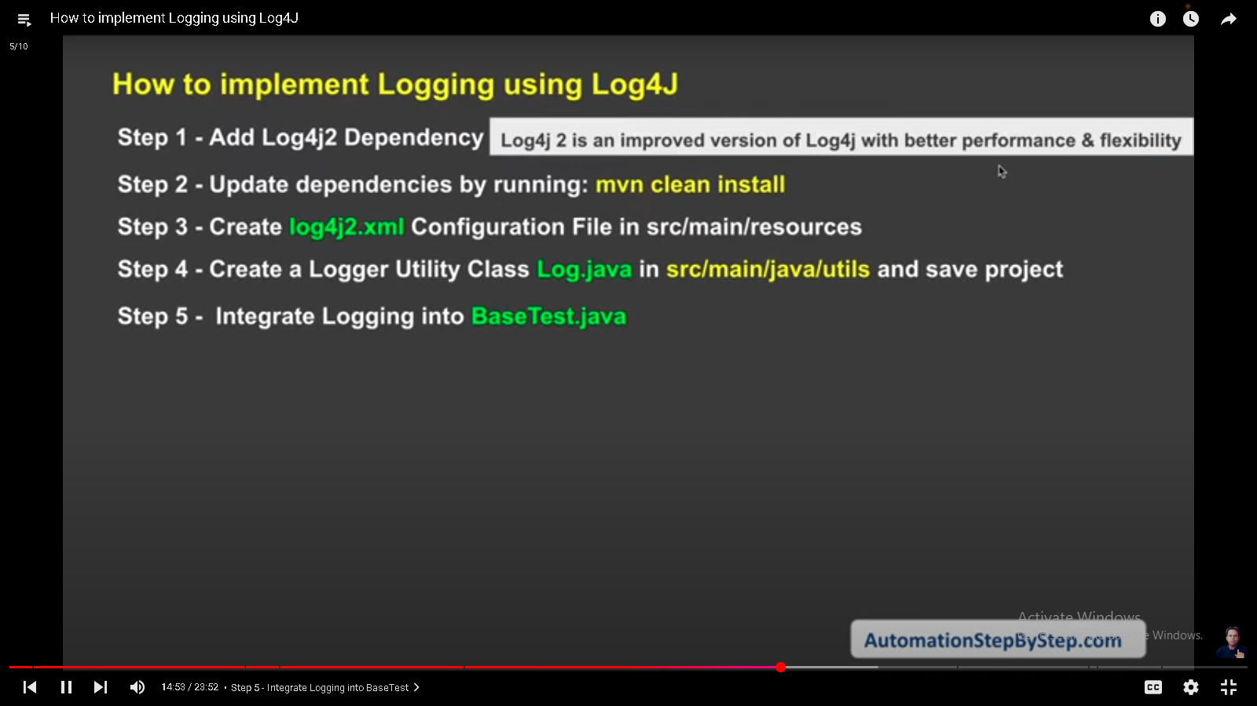

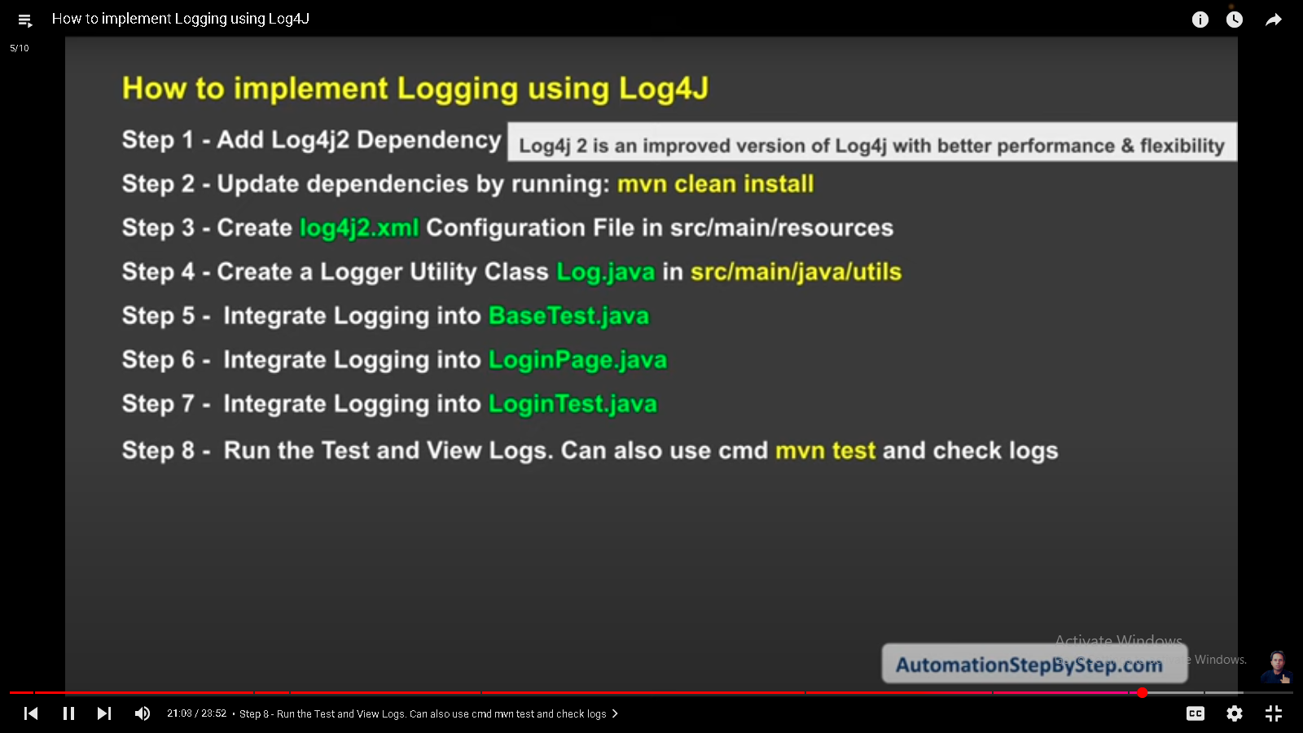

Run your test the and refresch your project incase you did not see the log folder in your project

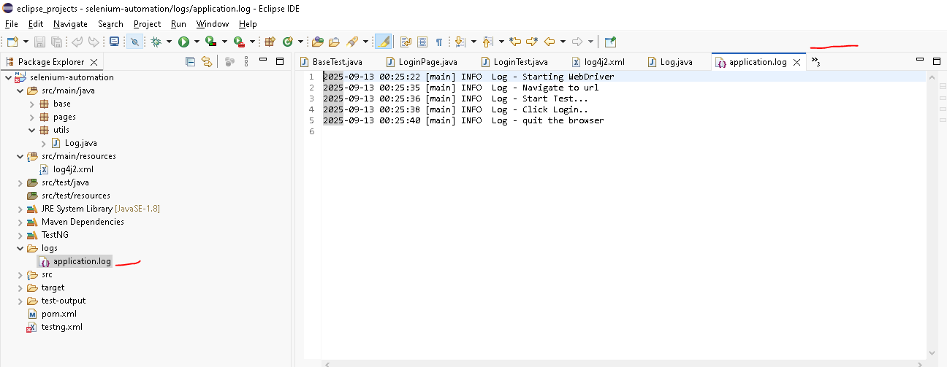

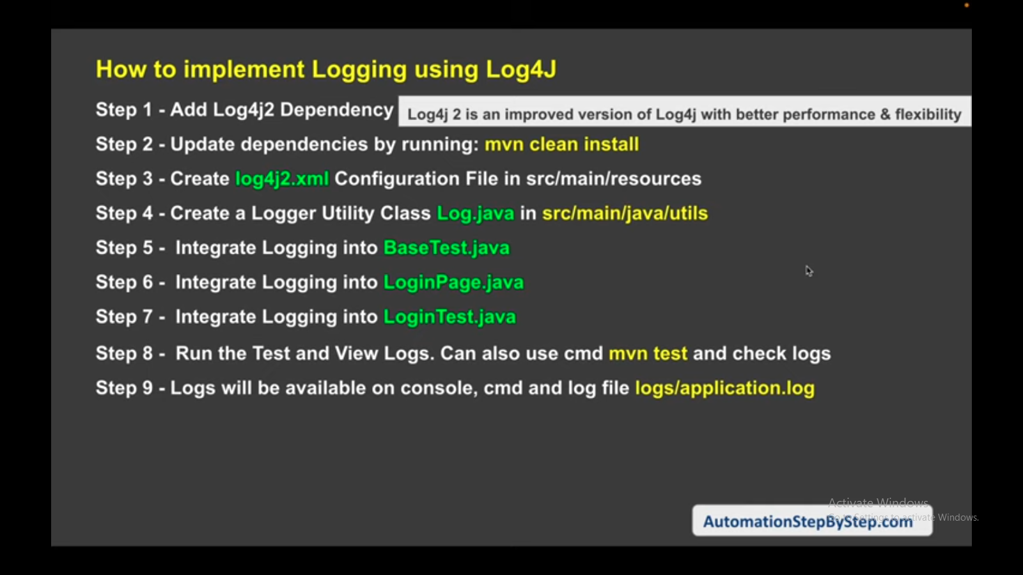

**ADDING extent REPORTS dependency in our pom.xml file:**

[**https://mvnrepository.com/artifact/com.aventstack/extentreports/5.0.9**](https://mvnrepository.com/artifact/com.aventstack/extentreports/5.0.9)

**Now create a new file under utils package in the name of** ExtentReportManager.java

Docs: <https://extentreports.com/>

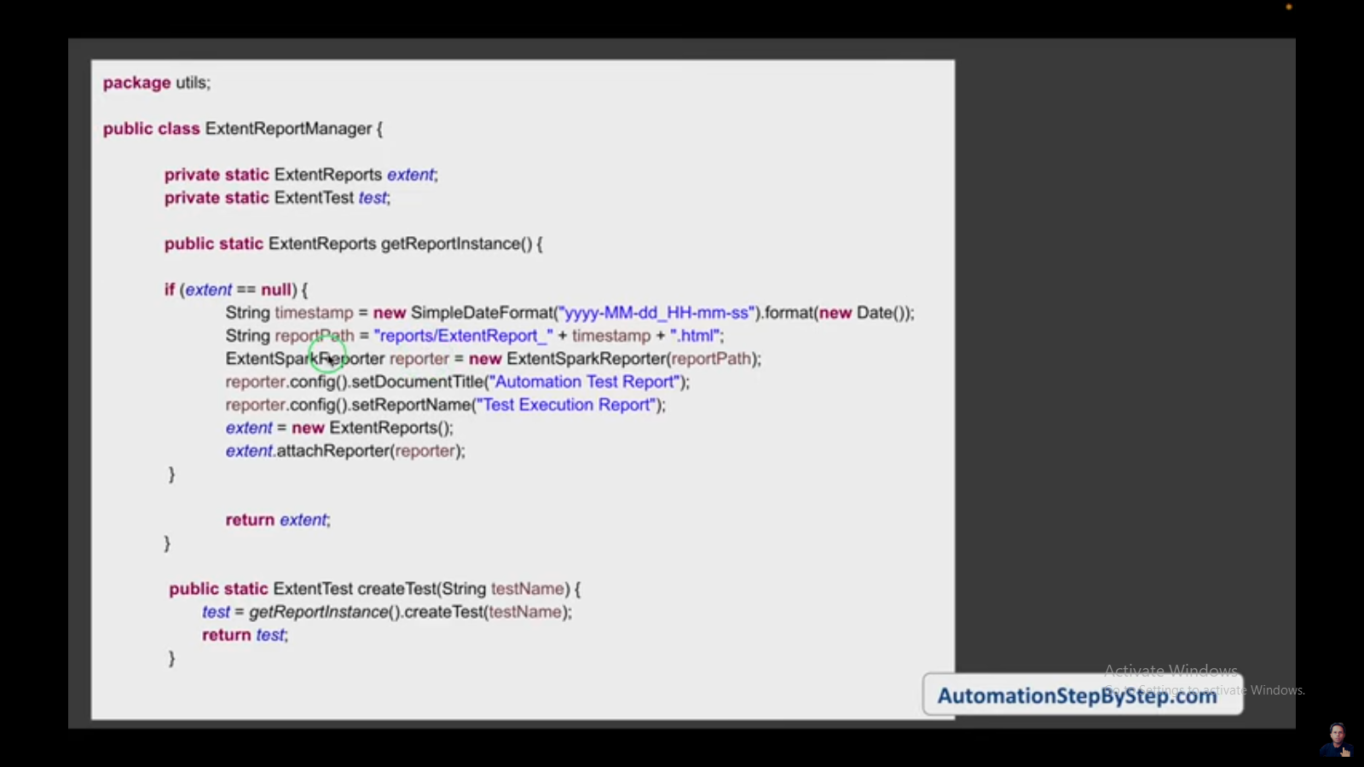

**package** utils;

**import** java.sql.Date;

**import** java.text.SimpleDateFormat;

**import** com.aventstack.extentreports.ExtentReports;

**import** com.aventstack.extentreports.ExtentTest;

**import** com.aventstack.extentreports.reporter.ExtentSparkReporter;

**public** **class** ExtentReportManager {

**private** **static** ExtentReports *extent*;

**private** **static** ExtentTest *test*;

**public** **static** ExtentReports getReportInstance() {

**if**(*extent* == **null**){

String timestamp = **new** SimpleDateFormat("yyyy-MM-dd_HH-mm-ss").format(**new** Date());

String reportPath = "reports/ExtentReport_"+timestamp+".html";

ExtentSparkReporter reporter = **new** ExtentSparkReporter(reportPath);

reporter.config().setDocumentTitle("Automation Test Report");

reporter.config().setReportName("Test Execution Report");

*extent* = **new** ExtentReports();

*extent*.attachReporter(reporter);

}

**return** *extent*;

}

**public** **static** ExtentTest createTest(String testName) {

*test* = *getReportInstance*().createTest(testName);

**return** *test*;

}

}

